2017 Resolutions
Adopted April 30, 2017

113th Annual State Convention
Mississippi Jurisdiction
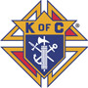
Knights of Columbus

